# ***How to deploy Transaction-History App on docker***

**App overview:**

Transaction-History Application - Docker Deployment

Our Transaction-History Application is Banging app to add money or doing transaction . To ensure seamless deployment, we have containerized the application using Docker.

Deployment Overview

We have implemented a multi-container setup using Docker Compose, which includes:

* Frontend: The user interface for interacting with medical billing data.
* MongoDB Database: A NoSQL database for securely storing medical billing records.

Dockerization Strategy

* We have written a Dockerfile to containerize the application.
* A Docker Compose file has been created to manage multiple containers efficiently.
* The application will be deployed in Docker containers, ensuring scalability and ease of management.
* Firstly, we need to launch one ec2 instance below are the steps 👇
* Loign to aws account and go to ec2 service dashboard

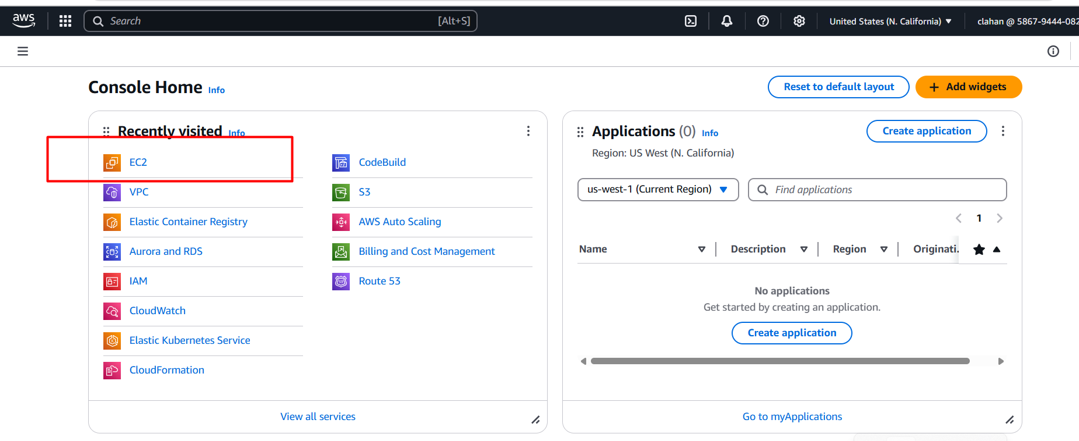

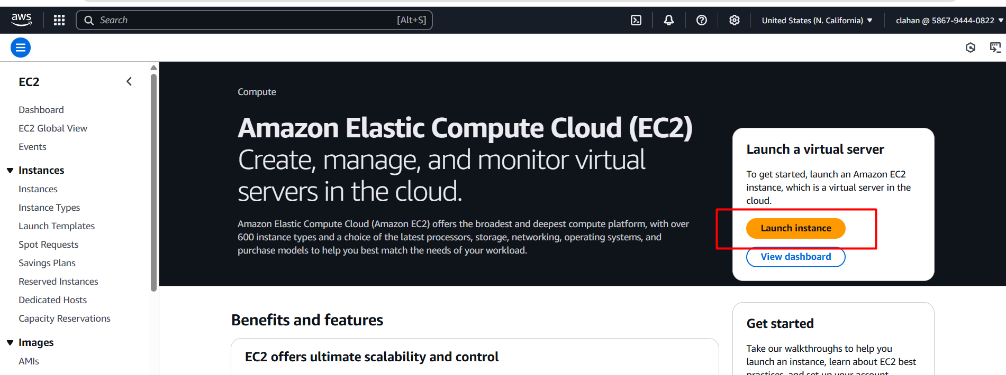

* Give a name for your ec2 instance as below image

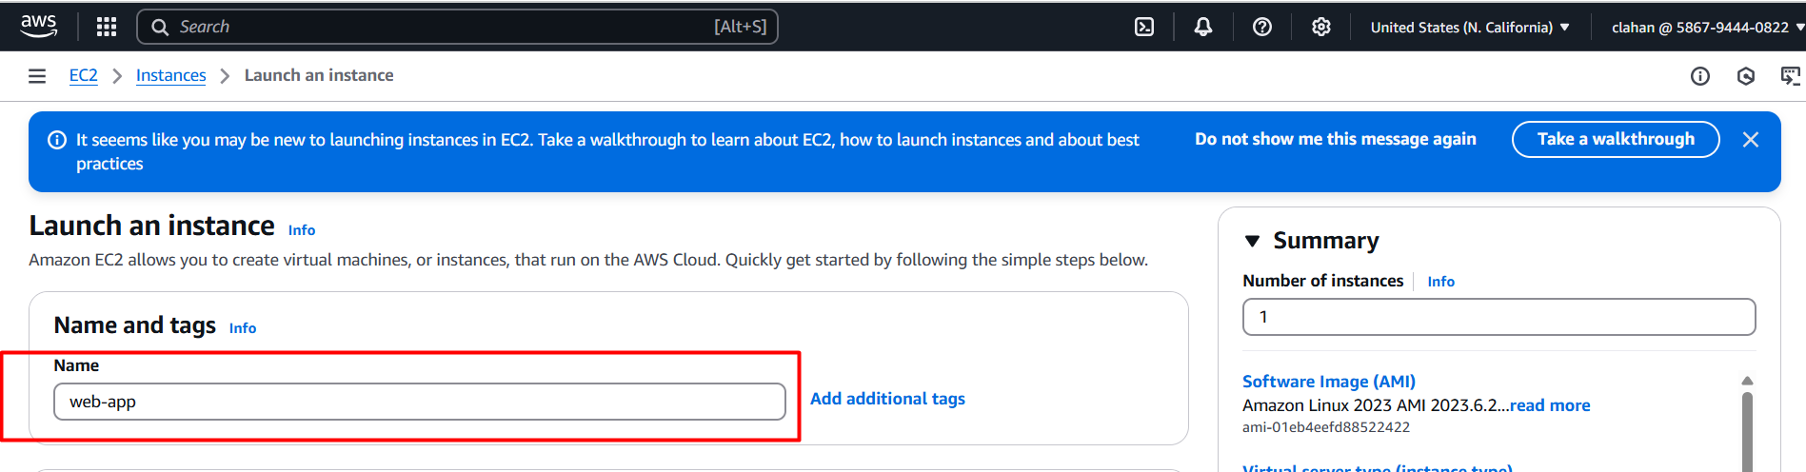

* Choose operating system ubuntu (in this case I am choosing ubuntu based on your requitement you can change the OS)

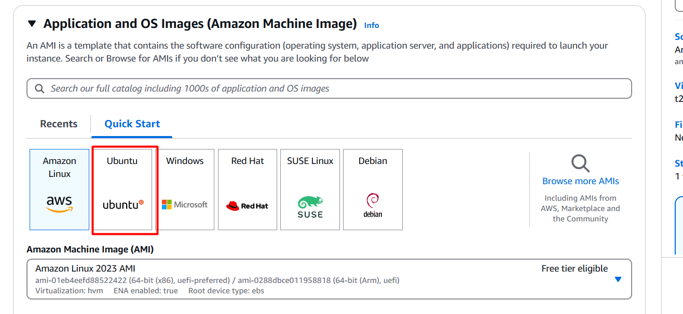

* Next choose instance type here I am choosing **t2.medium** for deploying simple static web app (but based on app requirement instance type will be changed)

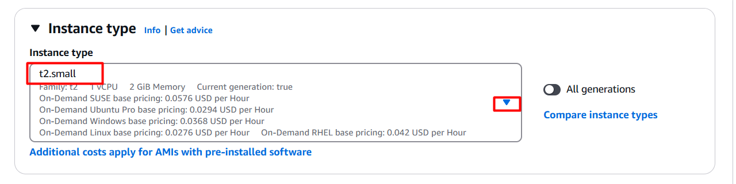

* Next, we need to key pair for connecting ec2 instance.
* How to create key pair follow below steps 👇
* Click on create new key pair

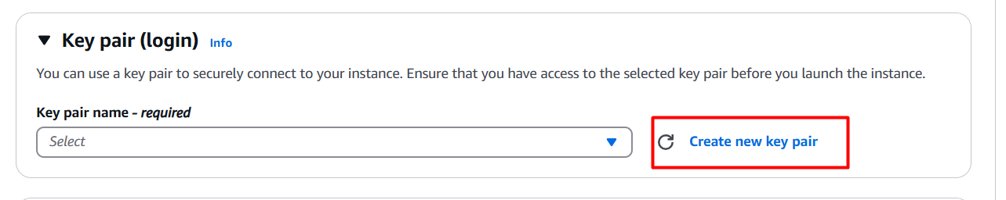

* Provide a name for key pair, select RSA, choose .ppk and click on create key pair 👇

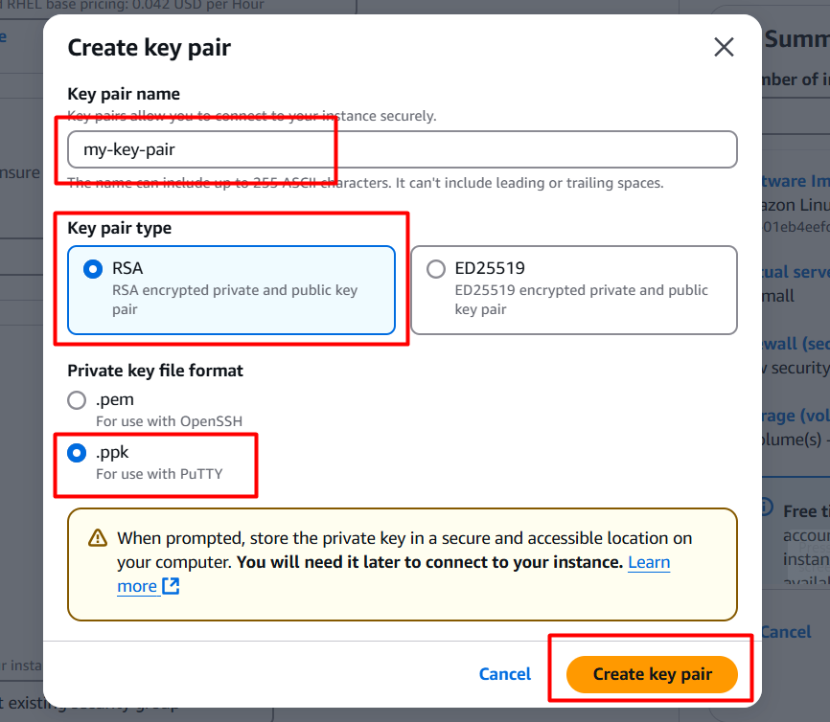

* It will be downloaded into your local server and go to file manager 🡪 downloads there you can see your new downloaded key pair

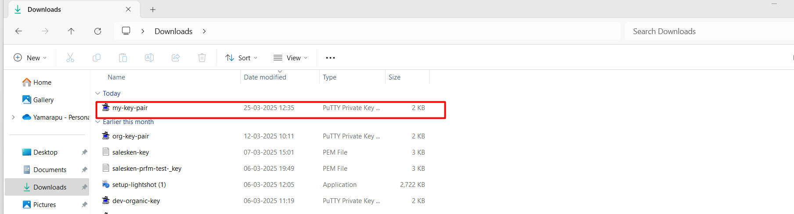

* Next in networking section we need to create one security group for enable port numbers 👇

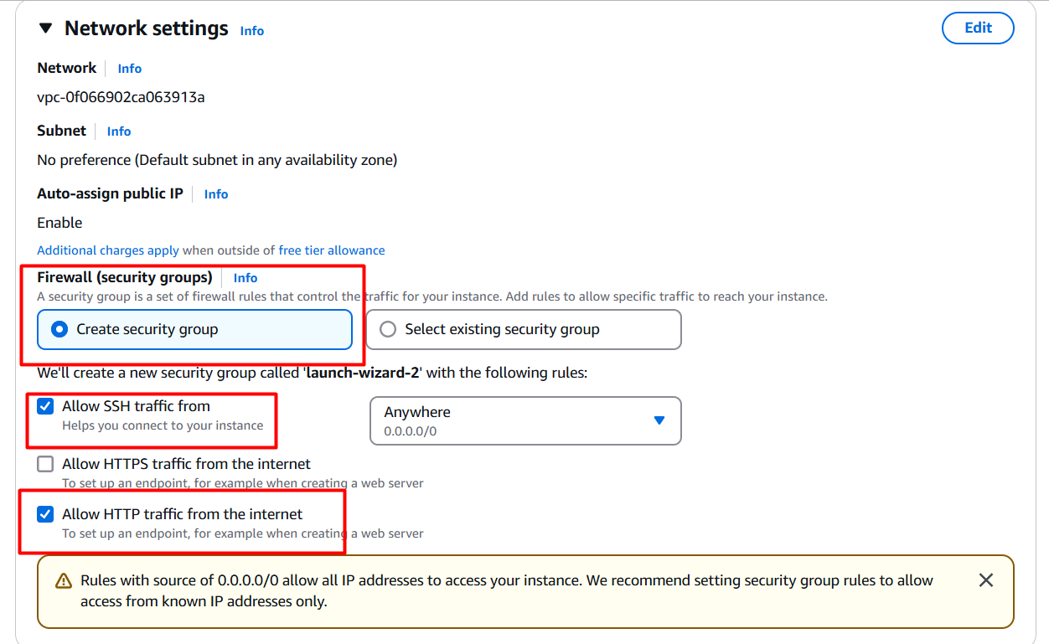

* Next we need to configure storage based upon app requirement , here I am choosing **20gb** for static web app 👇

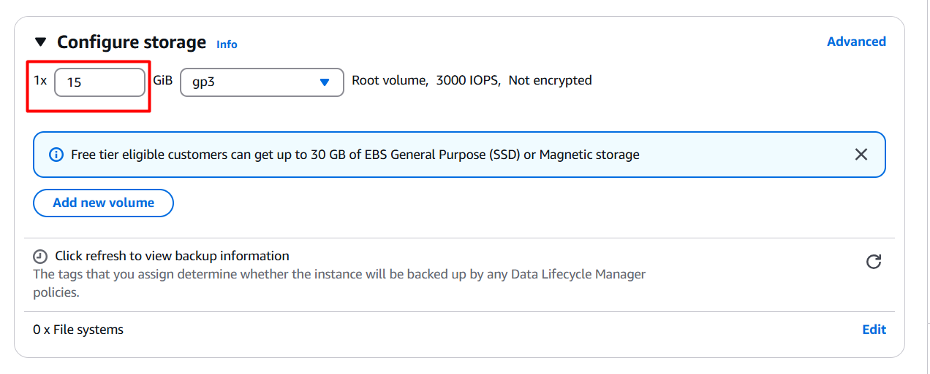

* Finally, we need to launch the ec2 instance 👇

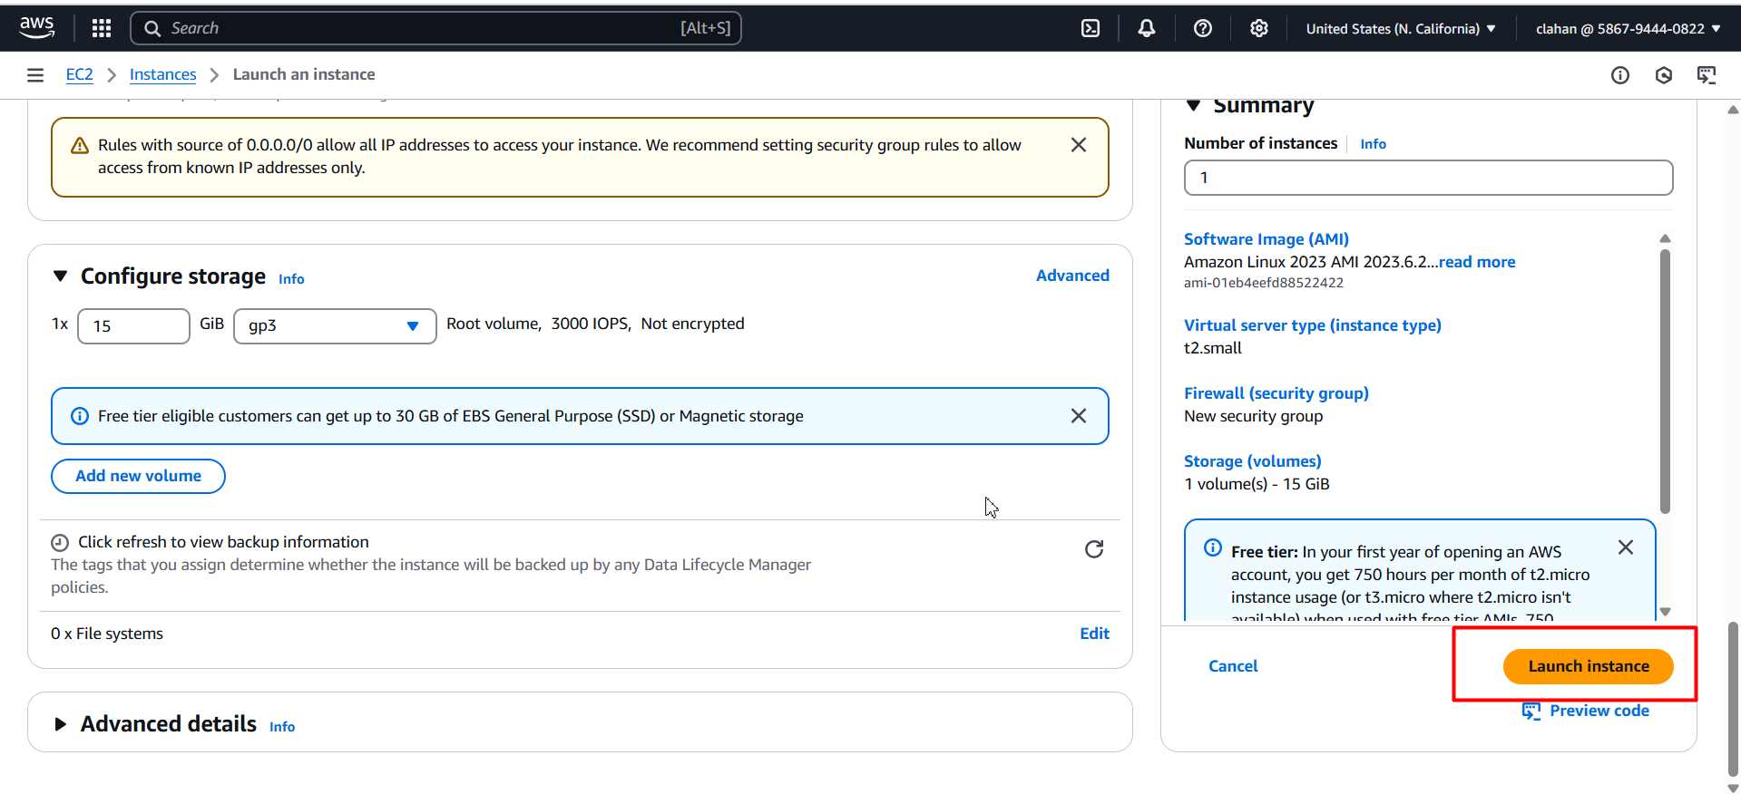

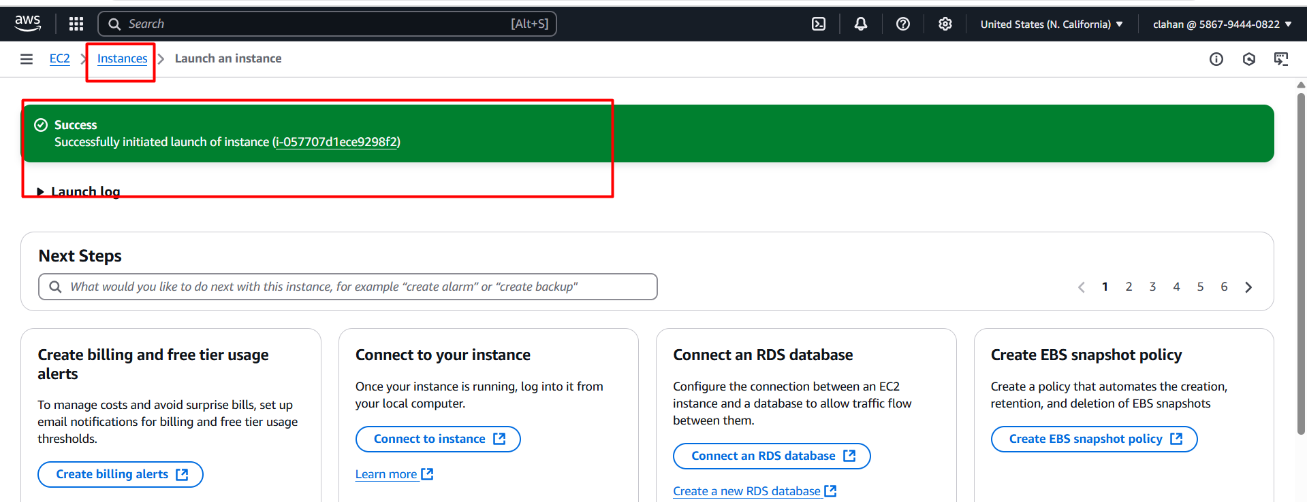

* Click on instances you can see your new created instance ☝️

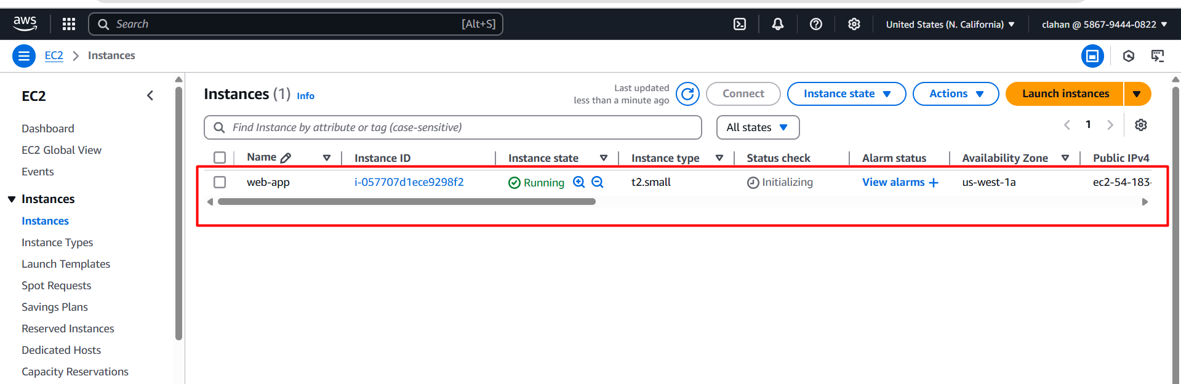

* open putty server on your local machine 👇

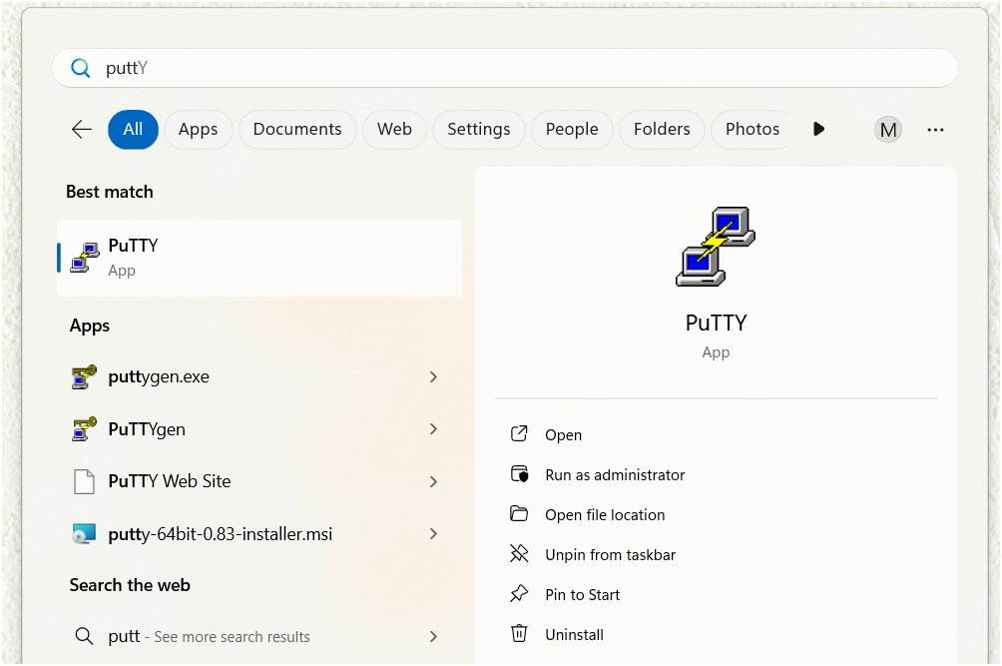

* It will open like this 👇

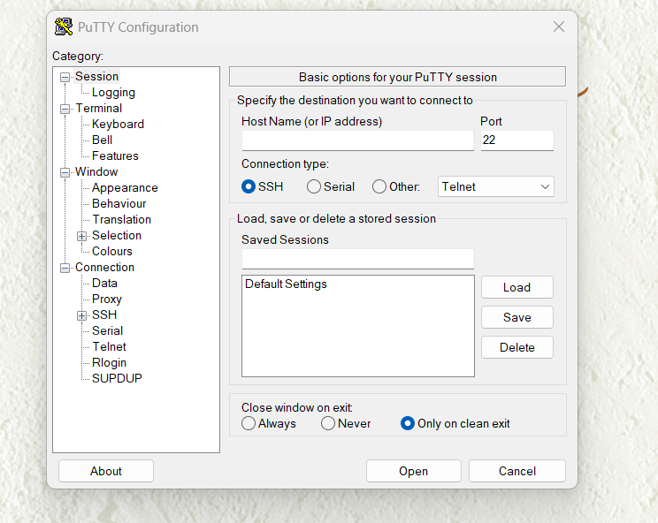

* Now go to your aws console and go to ec2 instance 👇



* Choose your instance and click on connect

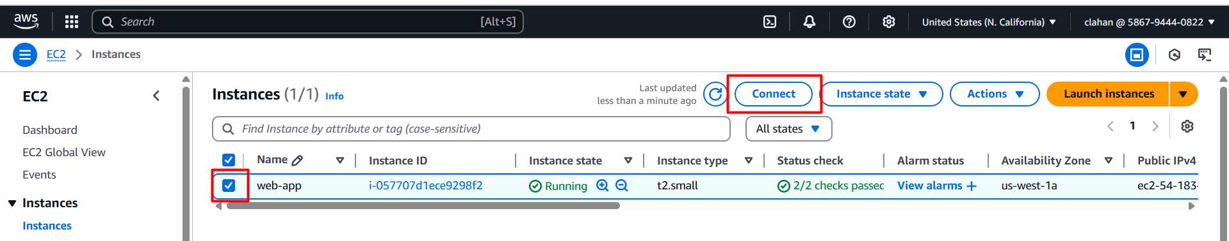

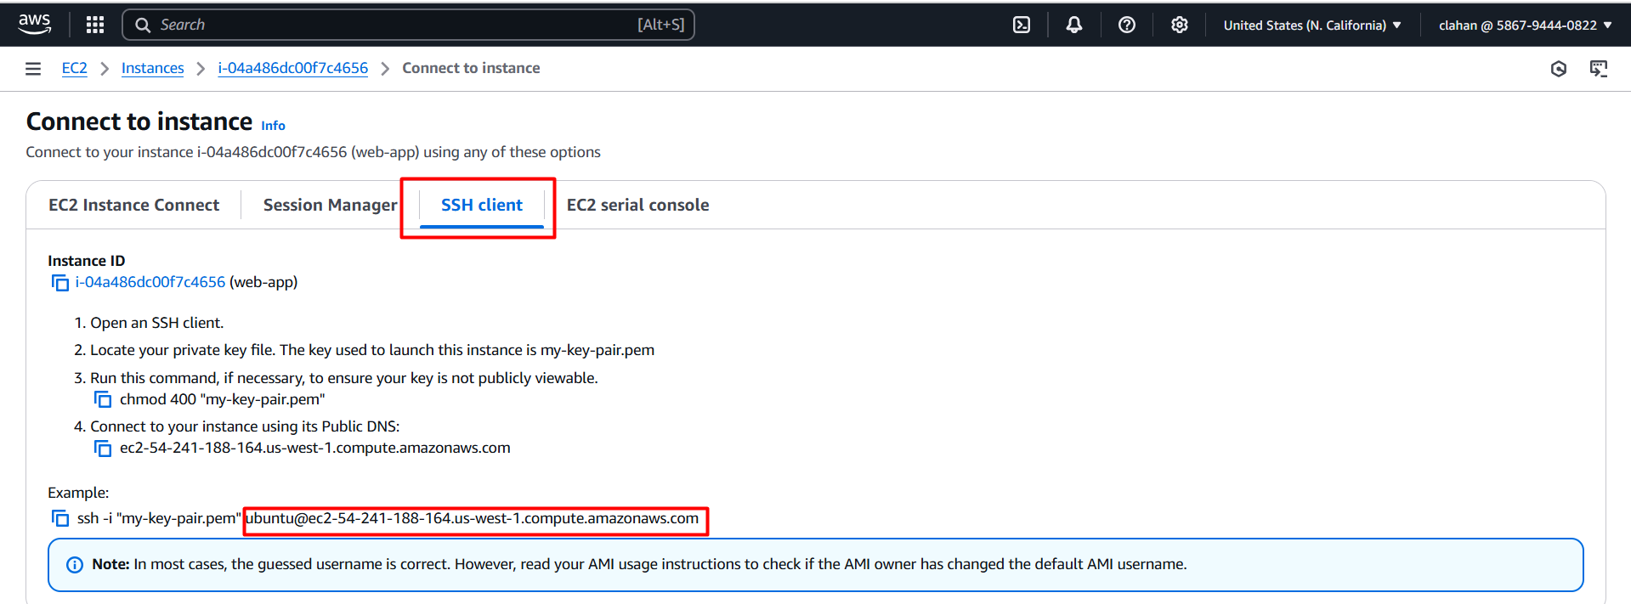

* Go to putty server enter copied host name as mentioned above image (second marked box)

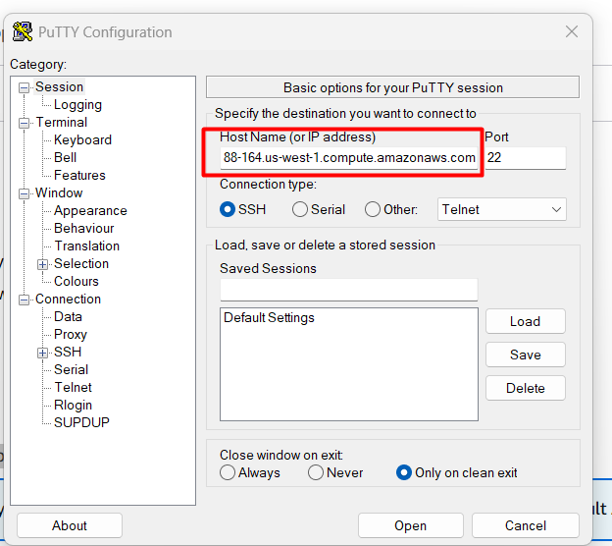

* Click on appearance and change for changing font size

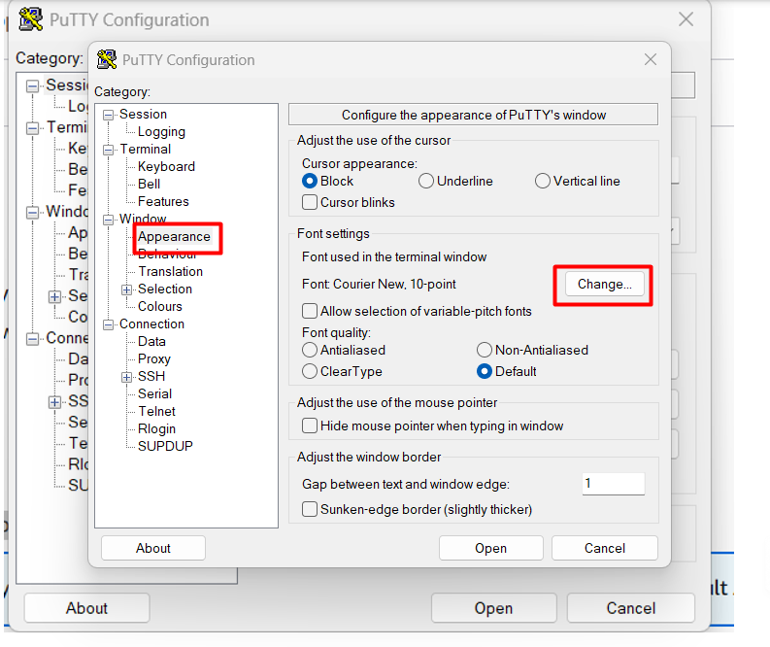

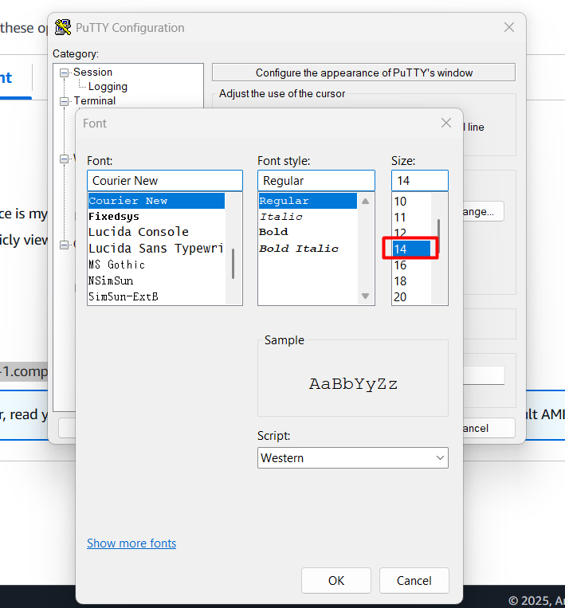

* Next click on connection and give 60 sec for timed out

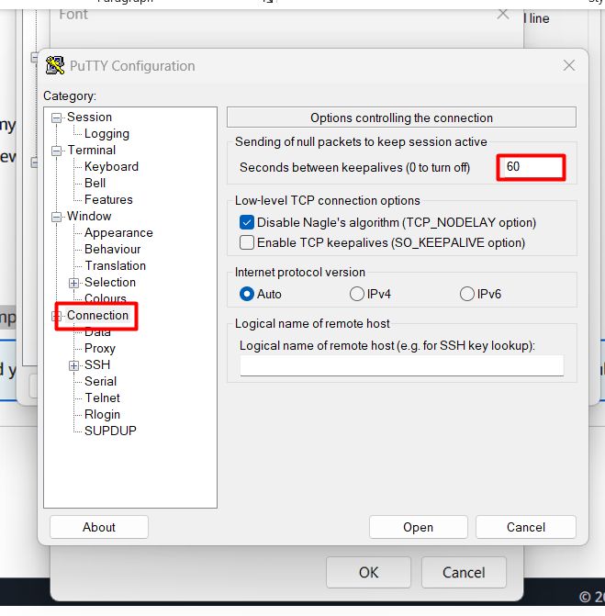

* Click on ssh 🡪 auth 🡪 credentials 🡪 browse

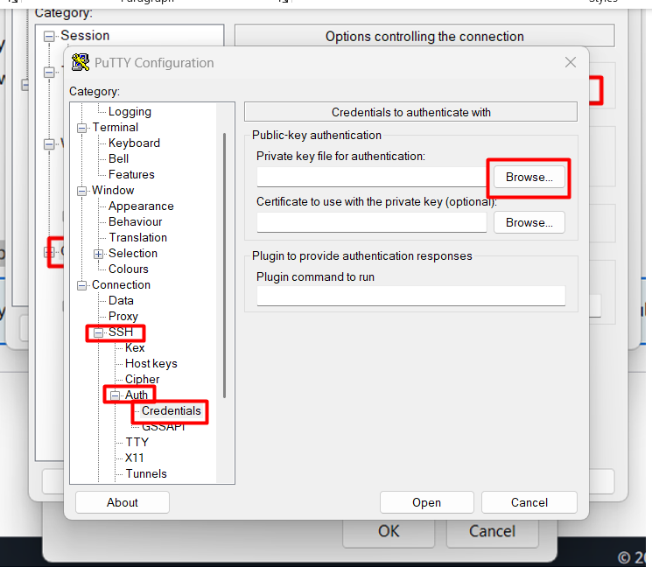

* After it will redirect into your file manager there choose your downloaded key pair

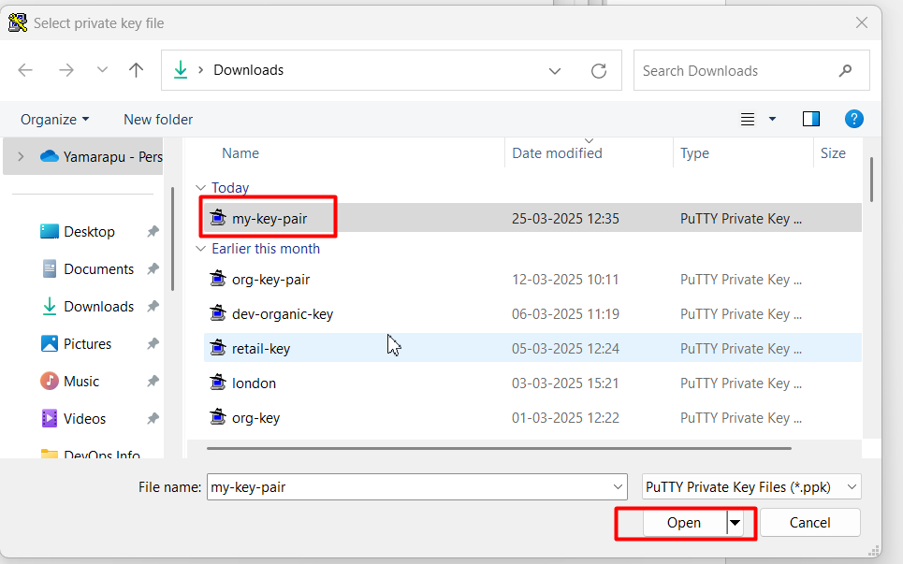

* Next again click on open

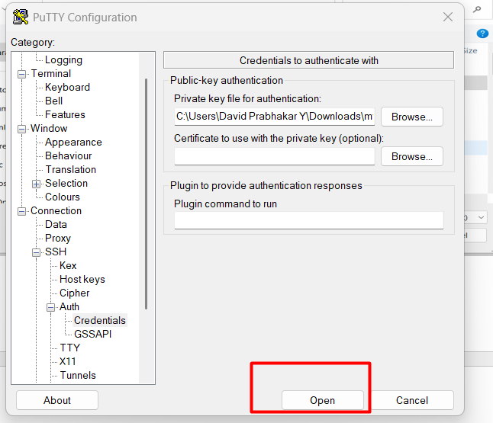

* Click on acceptance

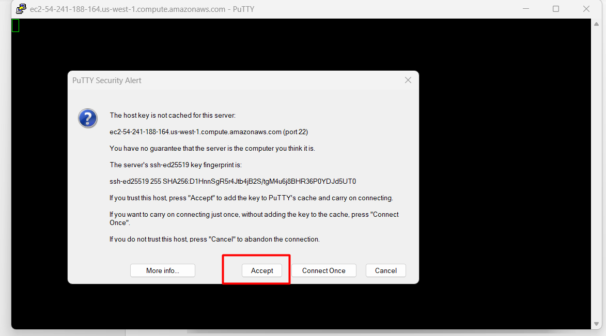

* Now you will connect to your server

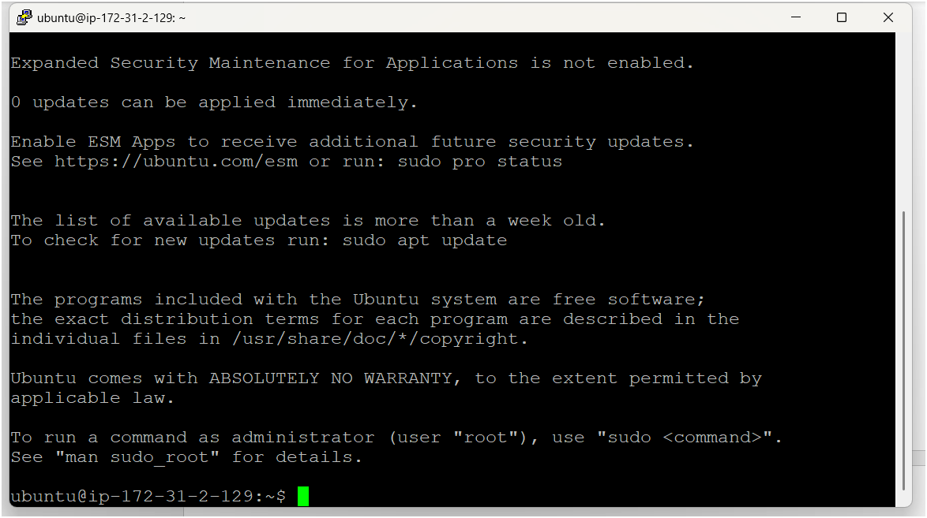

* After logged to server firstly you need to become as a root user

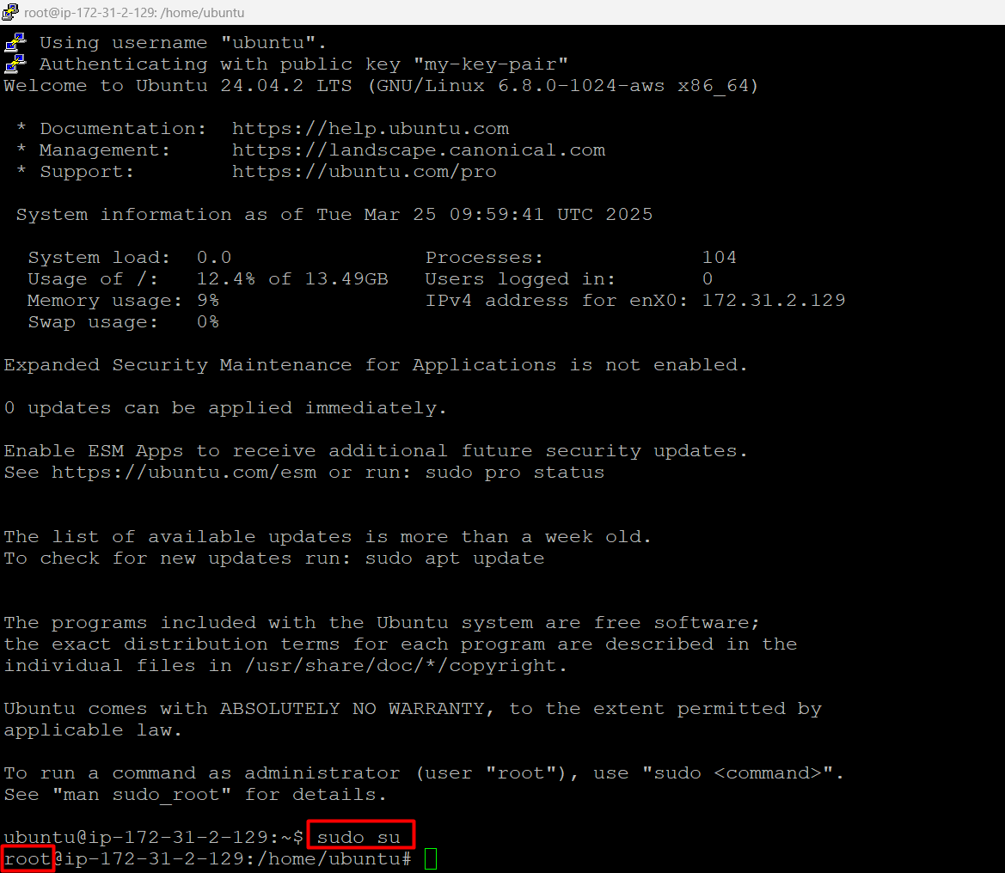

* Then update your server by using apt update -y

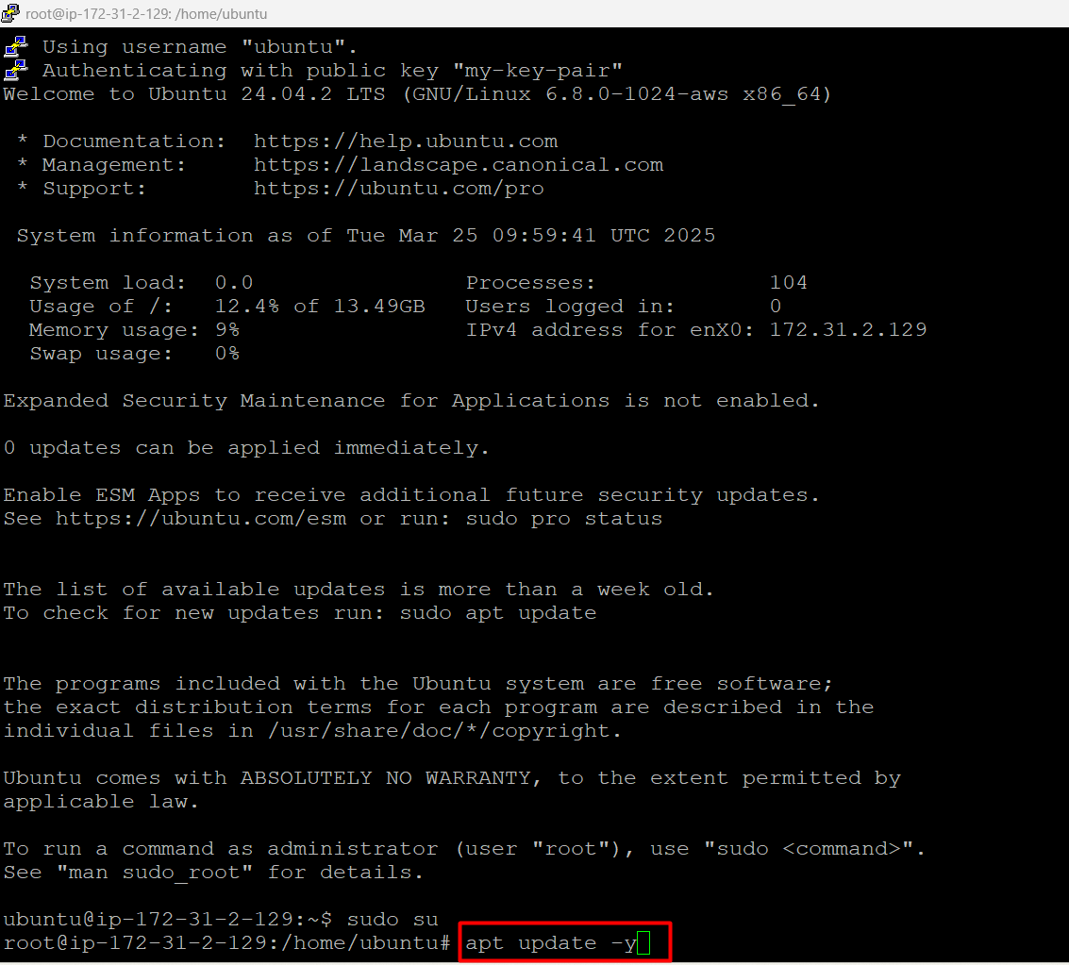

* Now we have to clone the repository into our server

<https://github.com/Msocial123/Transaction-History.git>

using below command

git clone <https://github.com/Msocial123/Transaction-History.git>

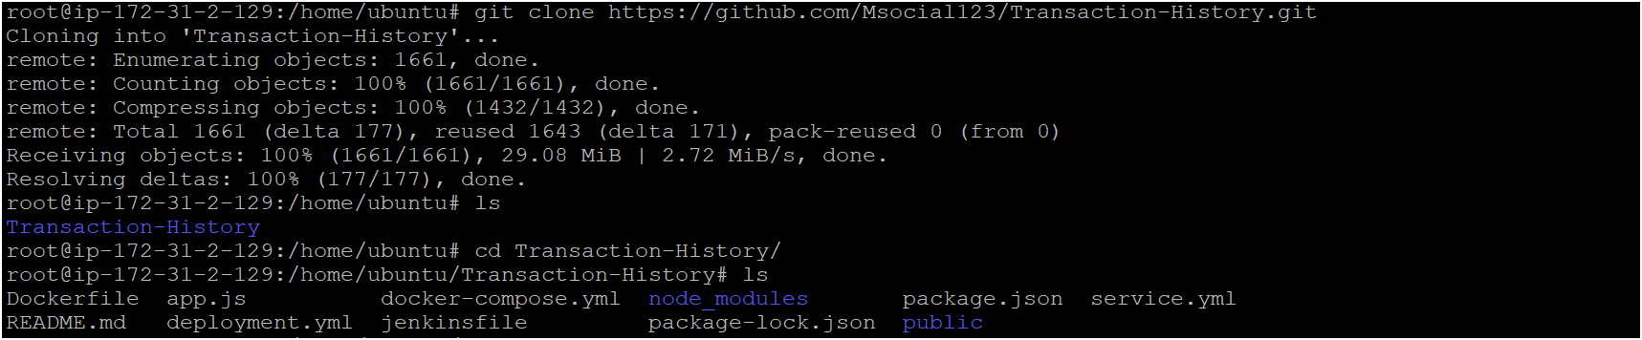

* Now install docker on ubuntu os/instance using below commands

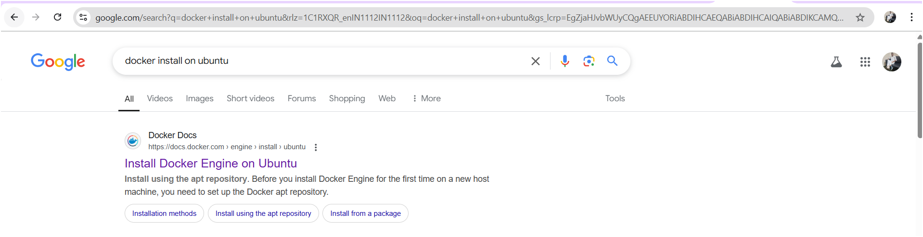

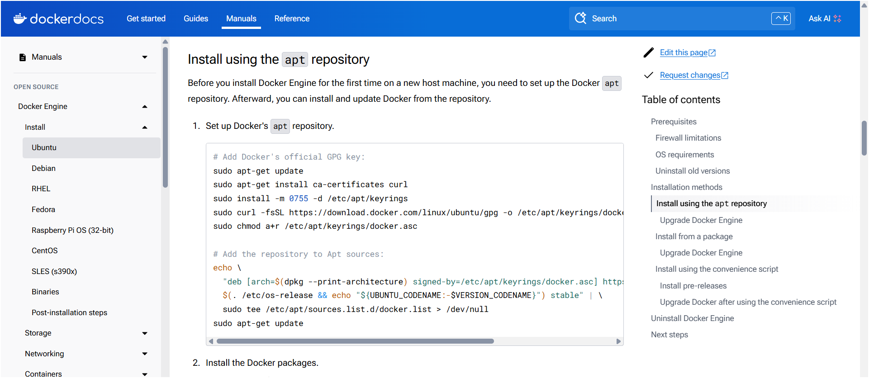

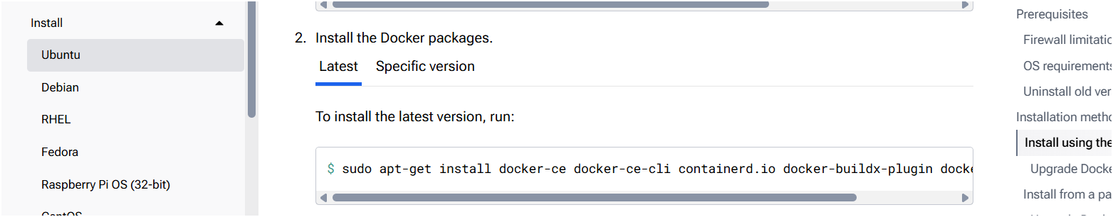

**Set up Docker's apt repository.**

# Add Docker's official GPG key:

sudo apt-get update

sudo apt-get install ca-certificates curl

sudo install -m 0755 -d /etc/apt/keyrings

sudo curl -fsSL https://download.docker.com/linux/ubuntu/gpg -o /etc/apt/keyrings/docker.asc

sudo chmod a+r /etc/apt/keyrings/docker.asc

# Add the repository to Apt sources:

echo \

"deb [arch=$(dpkg --print-architecture) signed-by=/etc/apt/keyrings/docker.asc] https://download.docker.com/linux/ubuntu \

$(. /etc/os-release && echo "${UBUNTU_CODENAME:-$VERSION_CODENAME}") stable" | \

sudo tee /etc/apt/sources.list.d/docker.list > /dev/null

sudo apt-get update

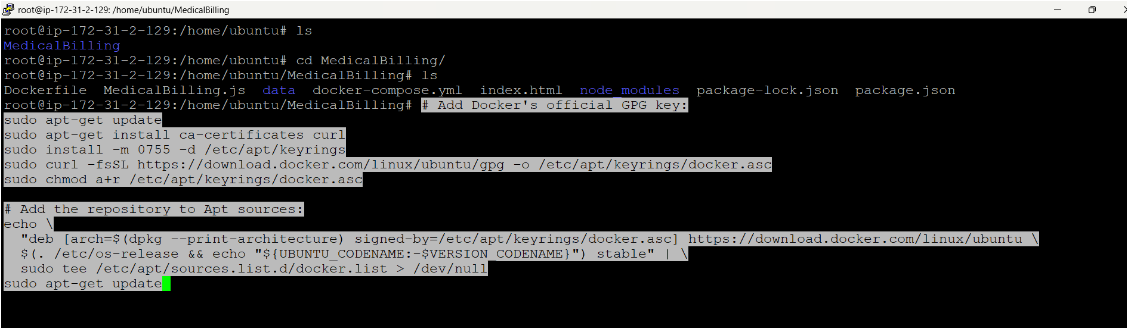

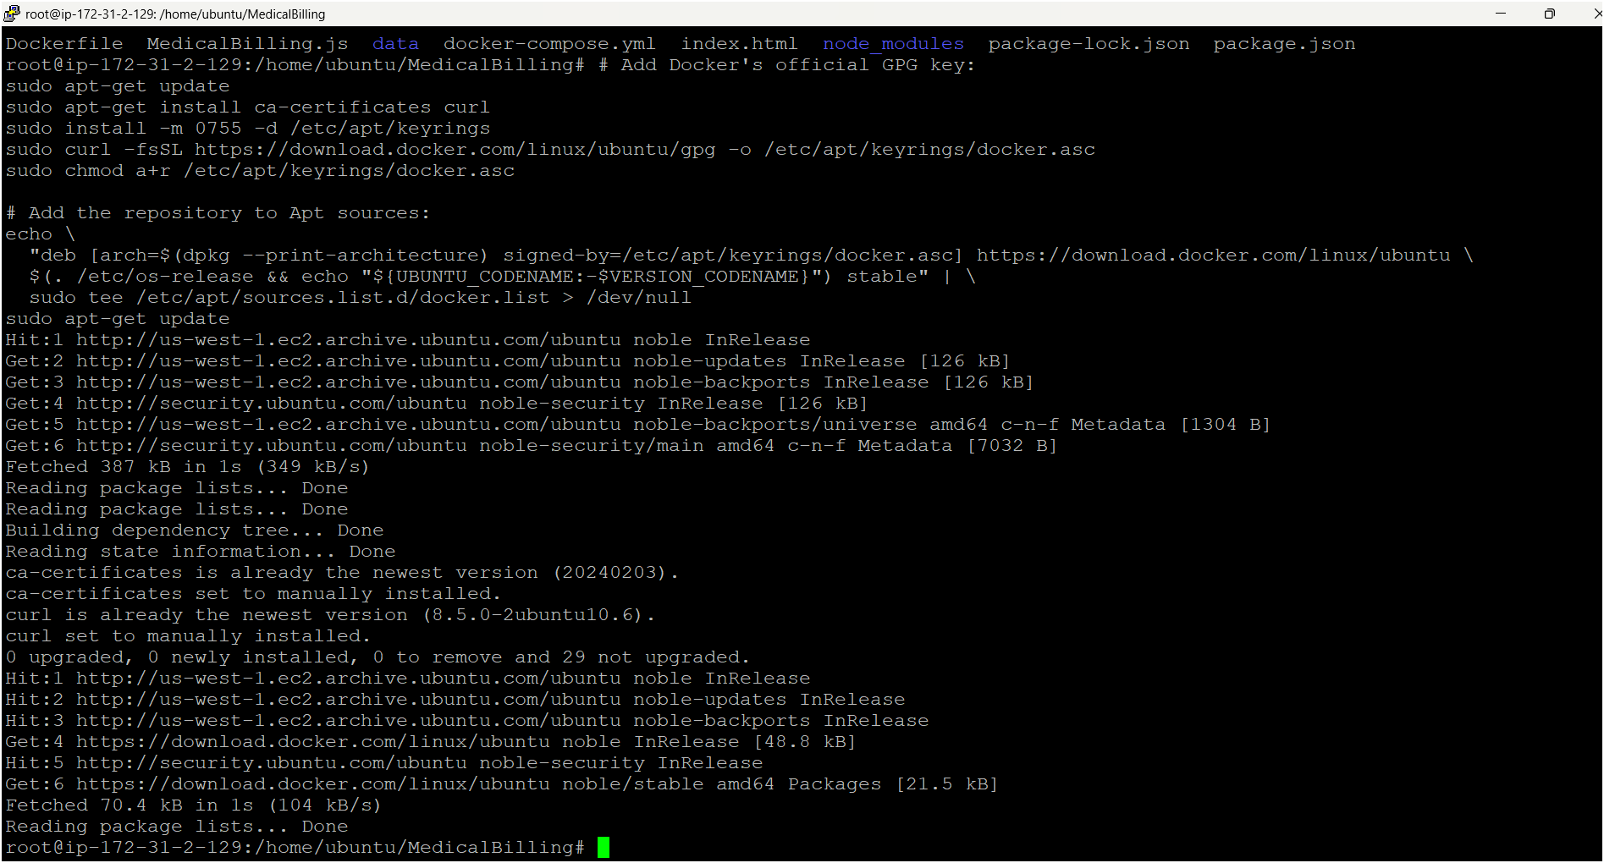

**Install the Docker packages.**

sudo apt-get install docker-ce docker-ce-cli containerd.io docker-buildx-plugin docker-compose-plugin



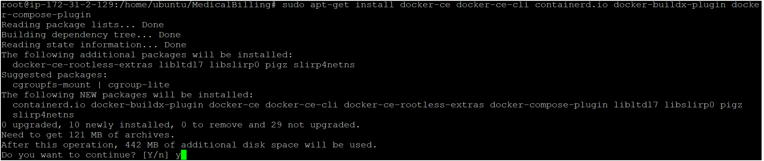

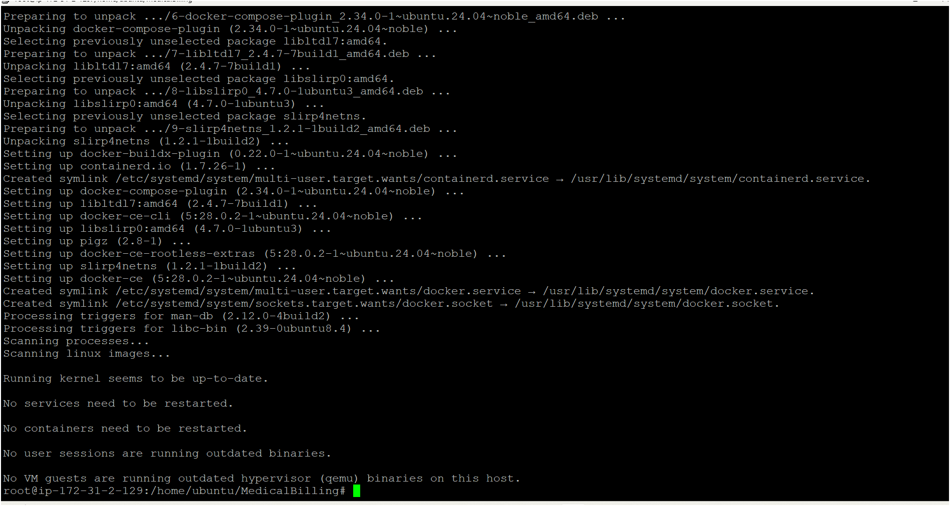

* Now check docker version whether its installed or not using below command

docker –verion

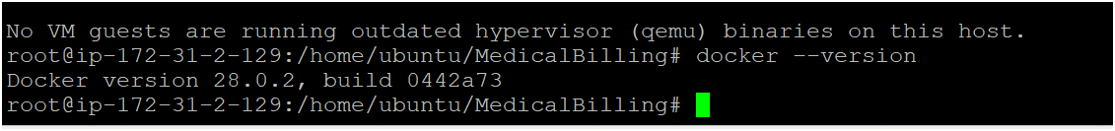

* If version is not visible manually restart docker using

service docker restart

* Now deploy the app by running docker compose file 👇

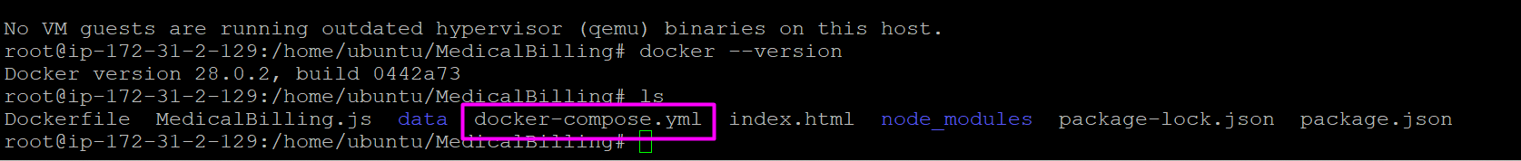

use this command for running compose yaml file

docker compose up -d

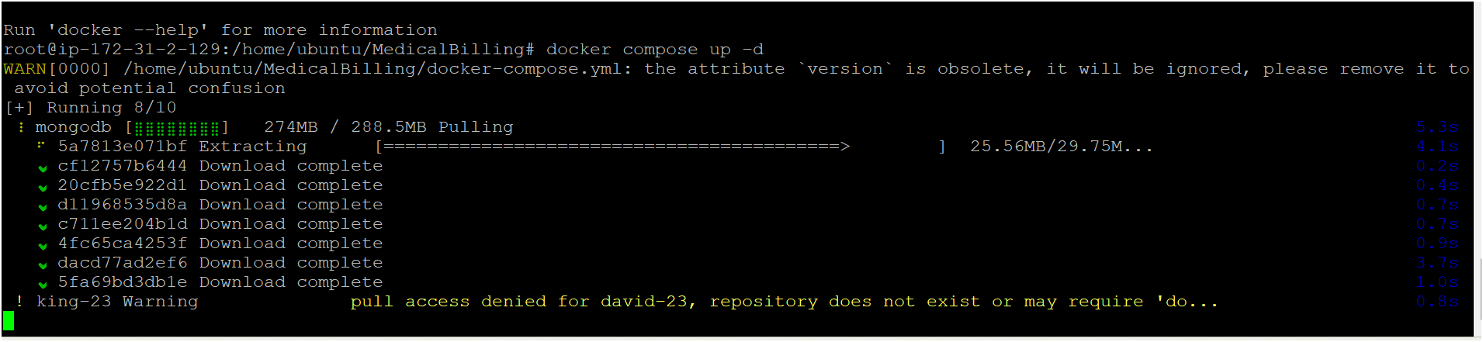

* Containers are created 👇

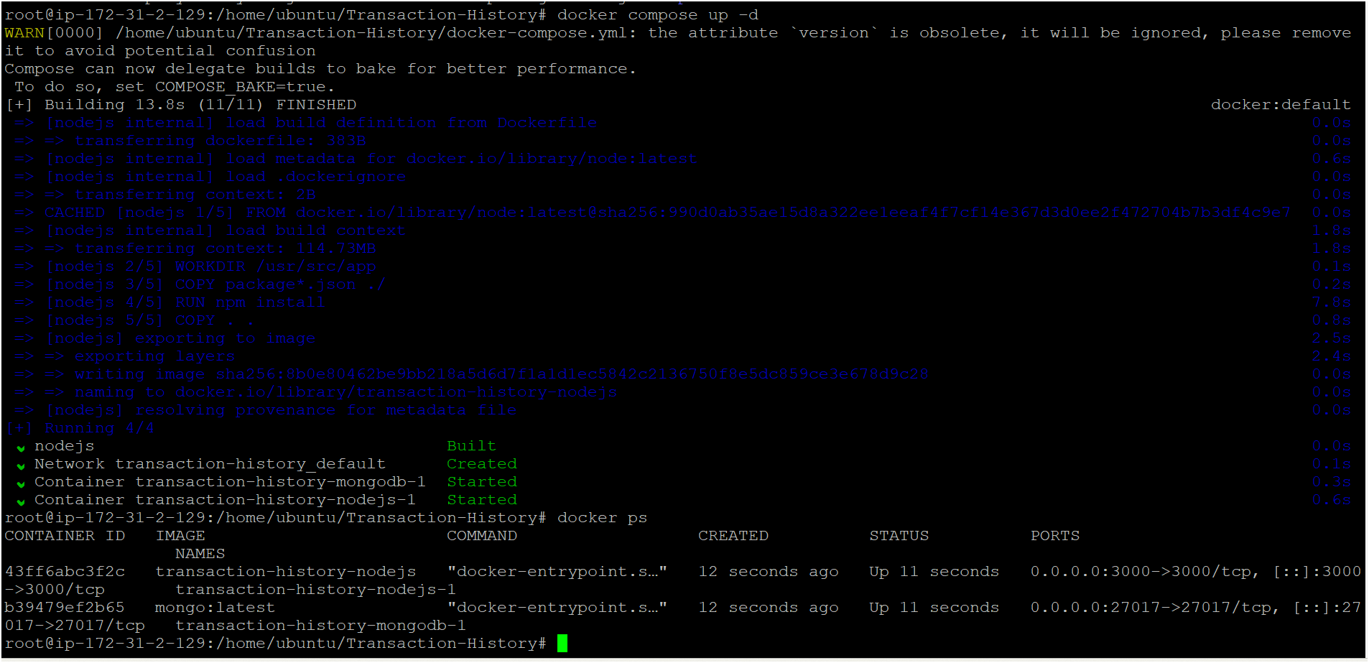

* Two containers are running successfully before accessing the app we need to open all tcp or app port number on ec2 instance security group

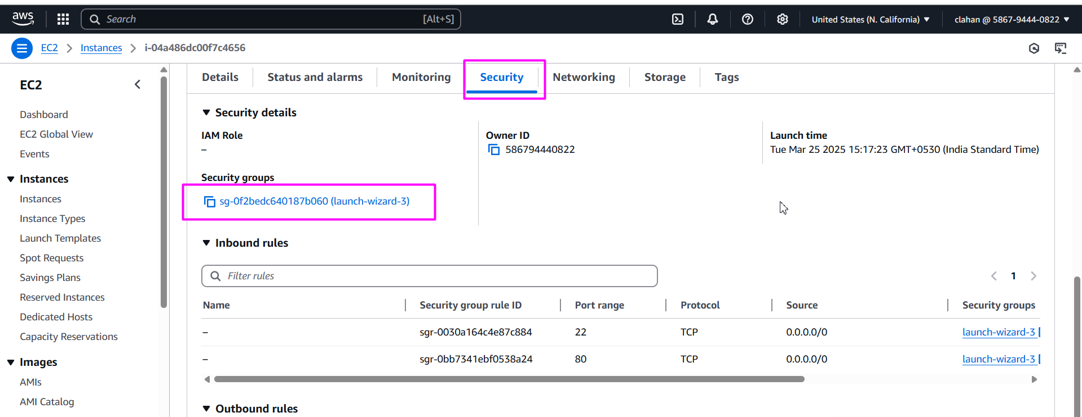

* Click on edit inbound rules

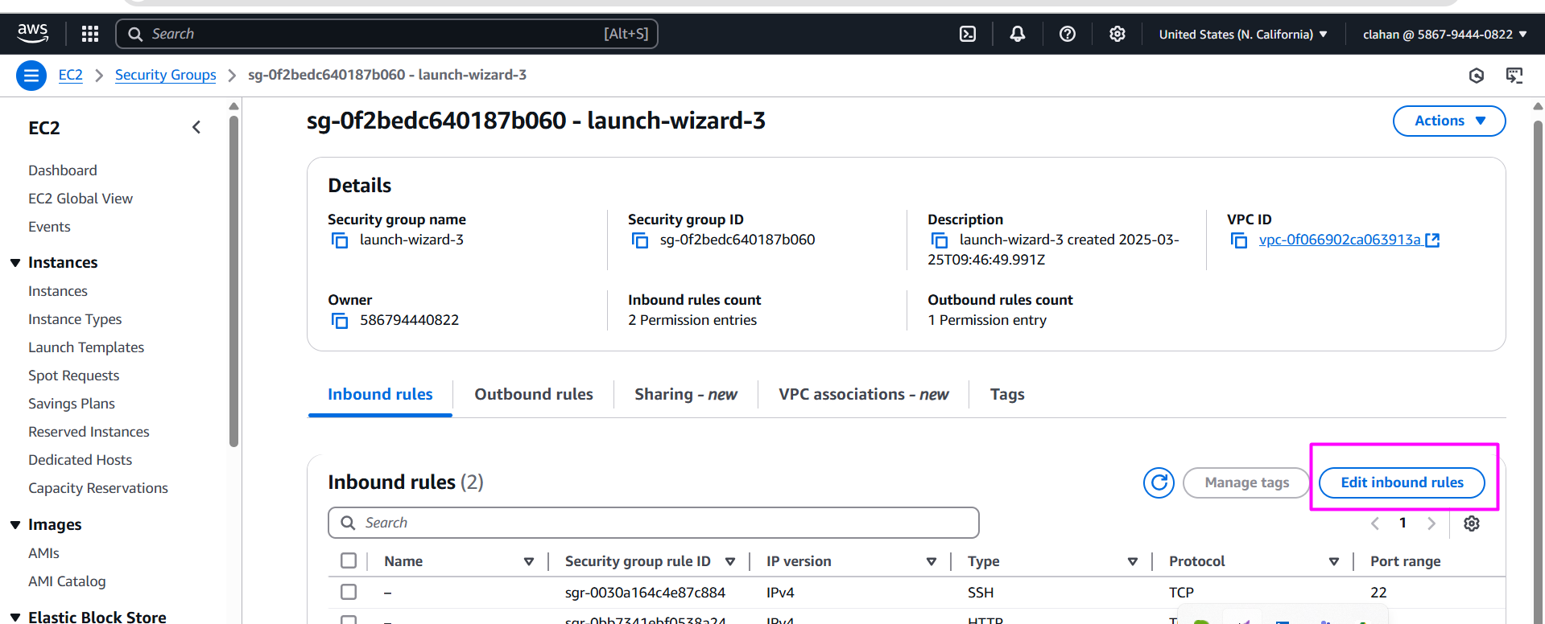

* Select all tcp if you want to open all port numbers or go with custom tcp if you want to open only individual port number and select anywhereipv2

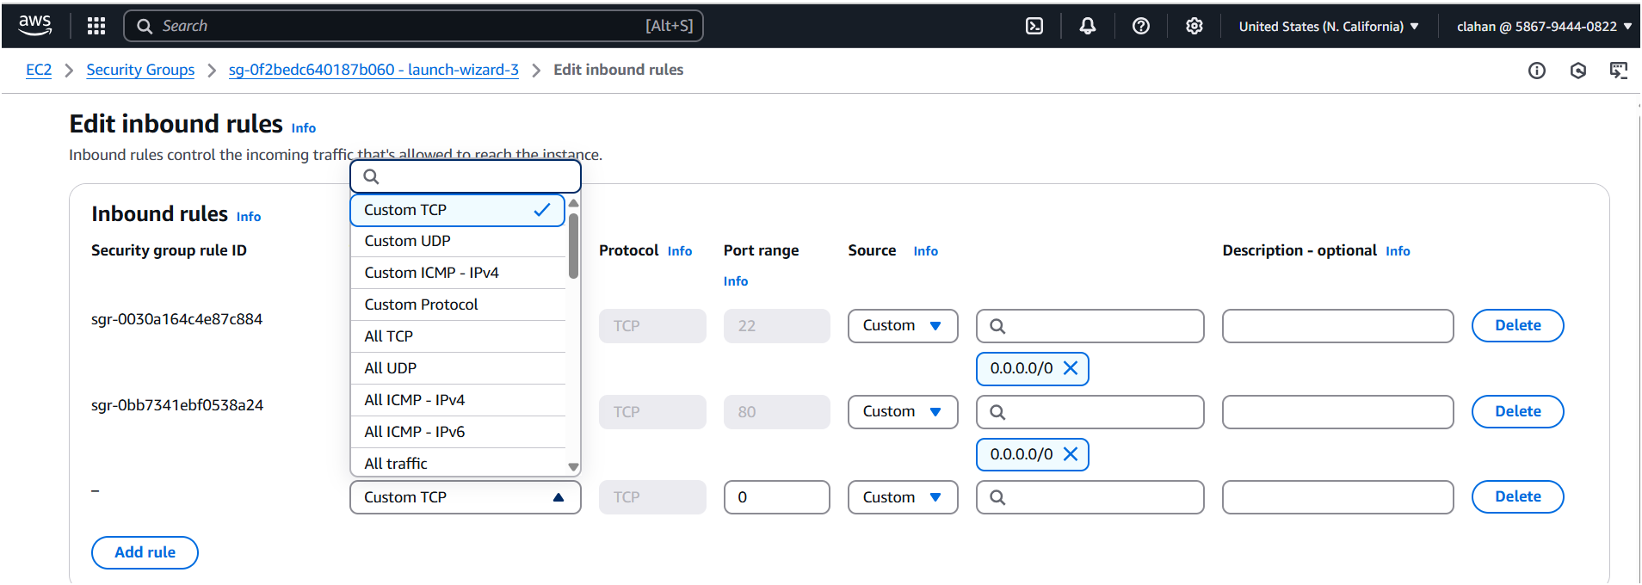

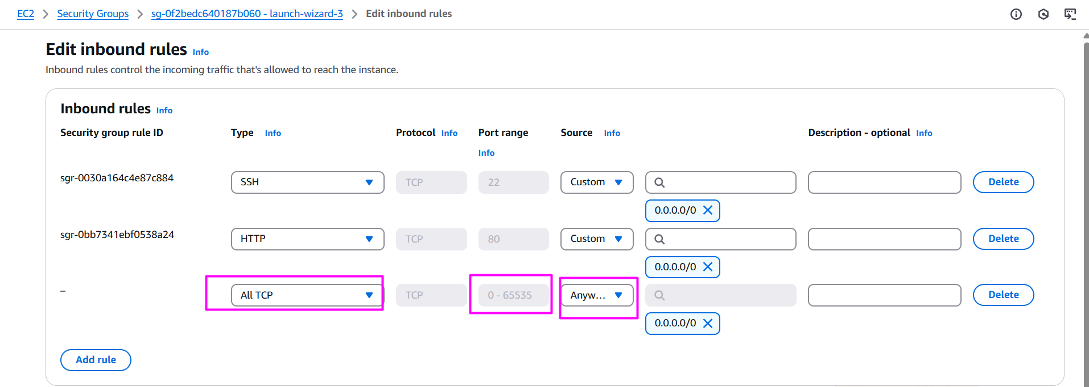

* Save your rule

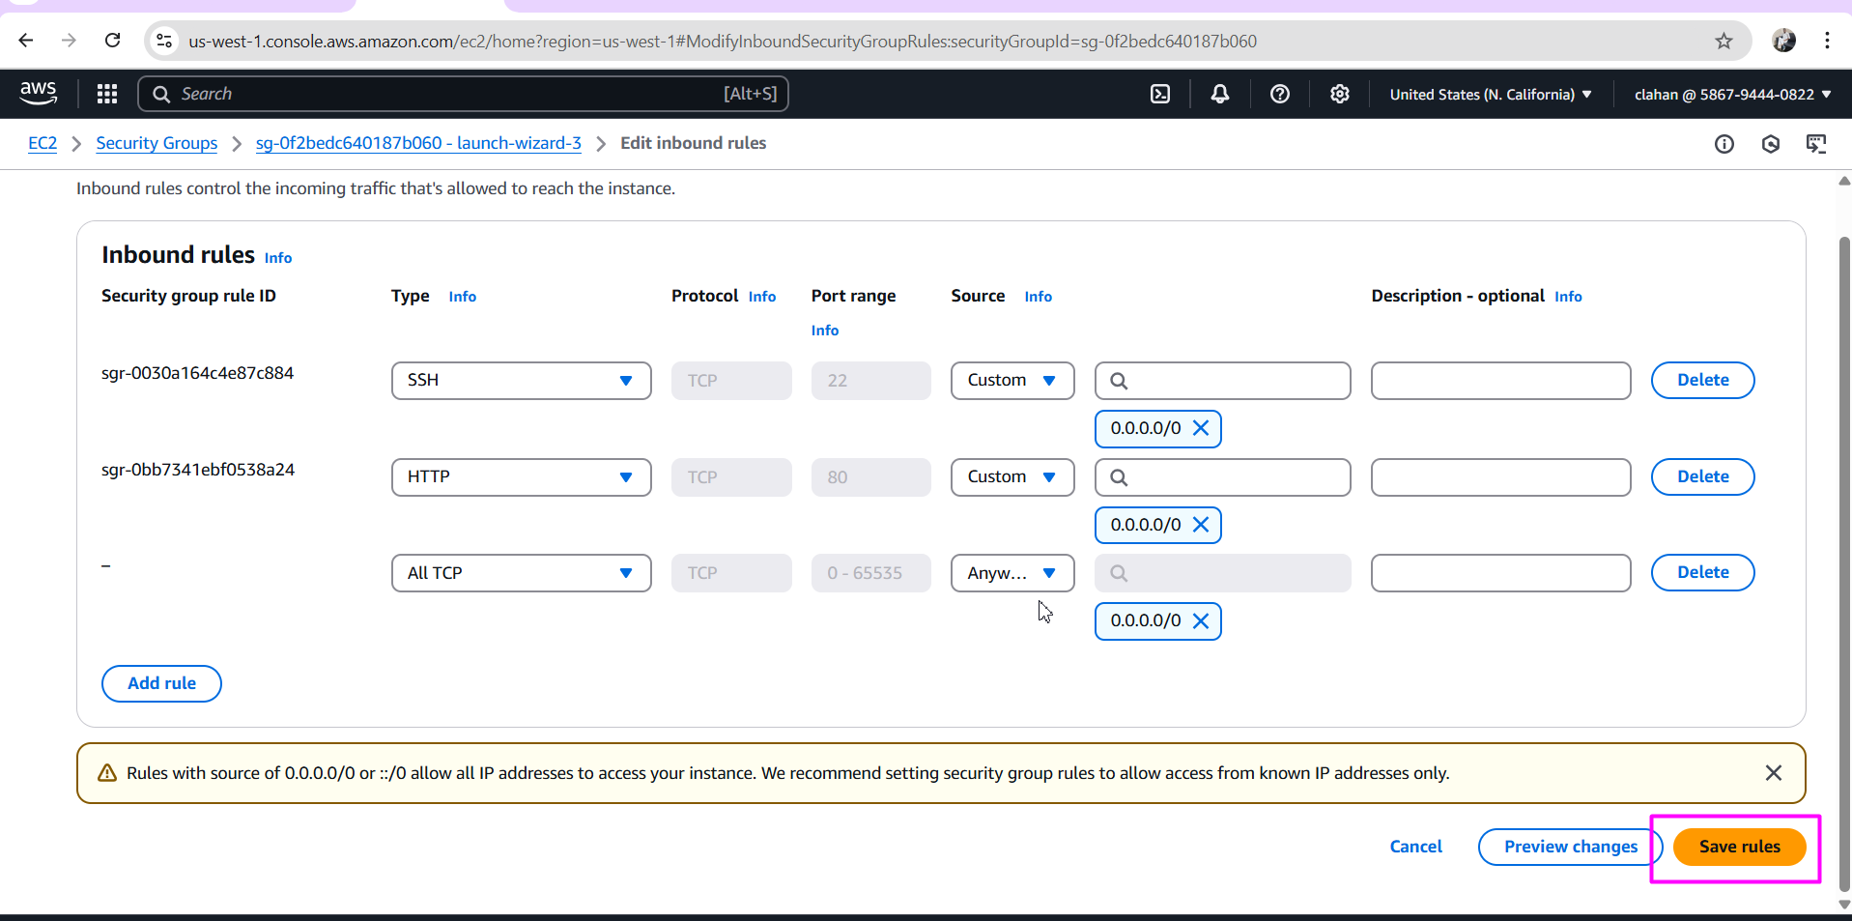

* Now access your app by using your instance public ip add with app port no ( before that you must enable port number on security group)

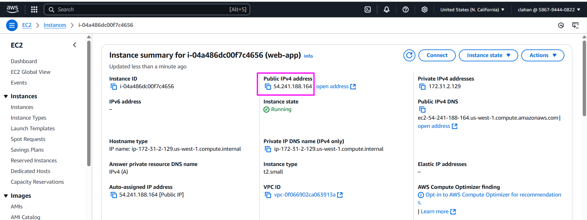

* Open browser paste ip address as shown the image 👇

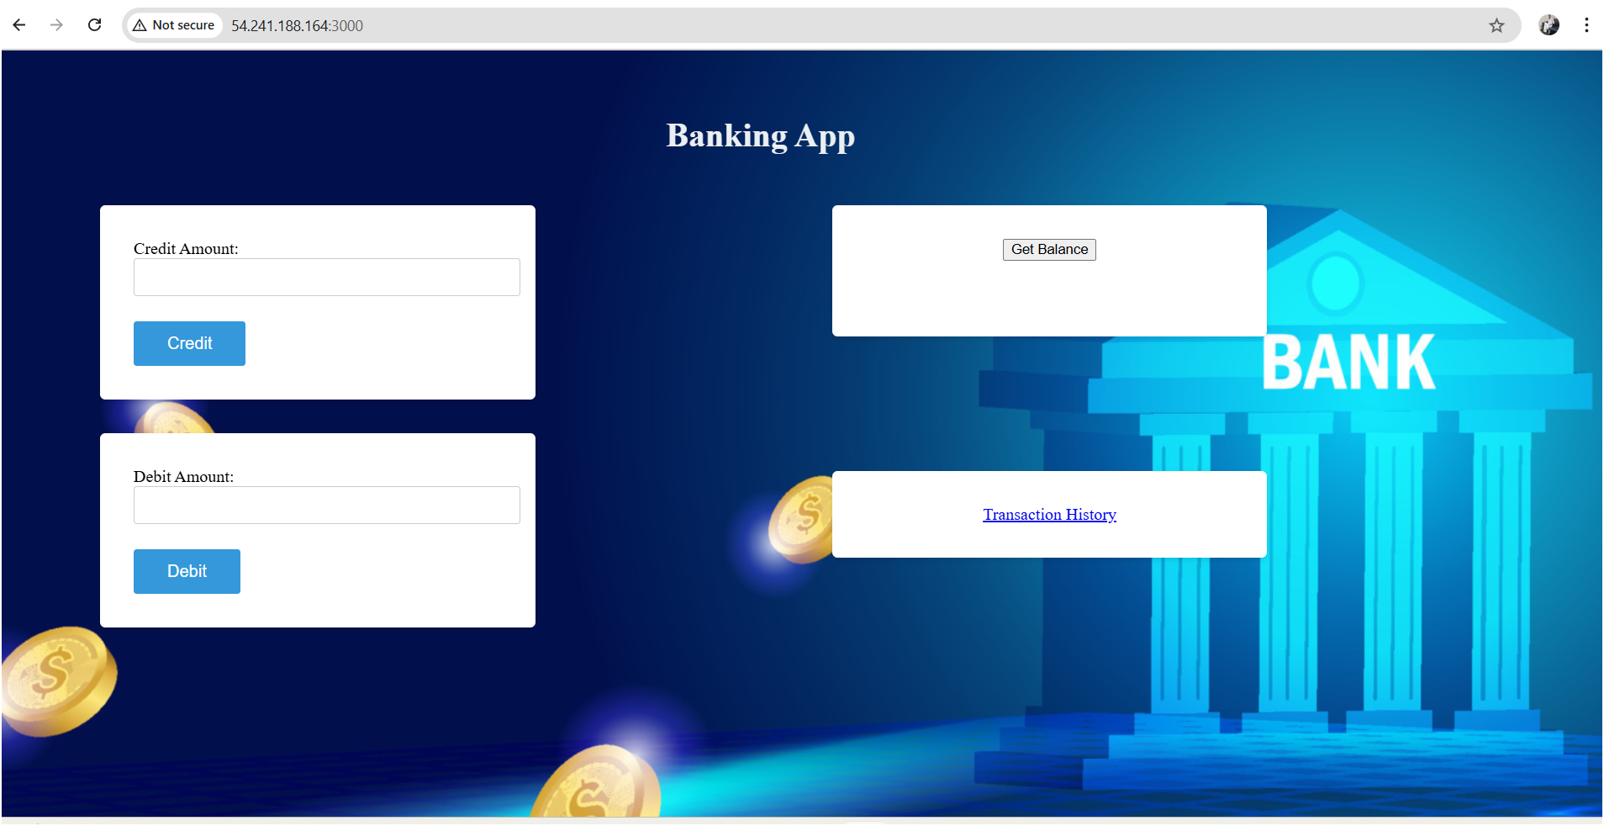

* Now delete all containers using below command

docker compose down

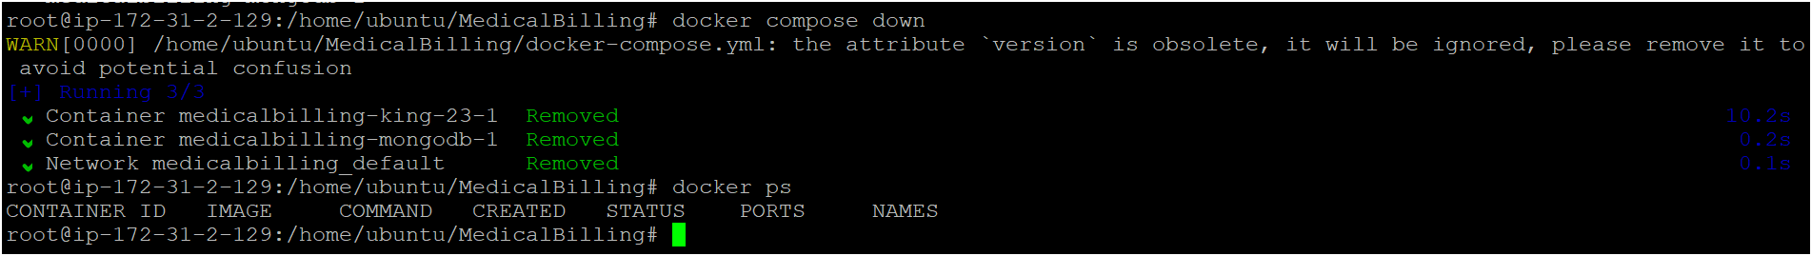

* Enter some amount

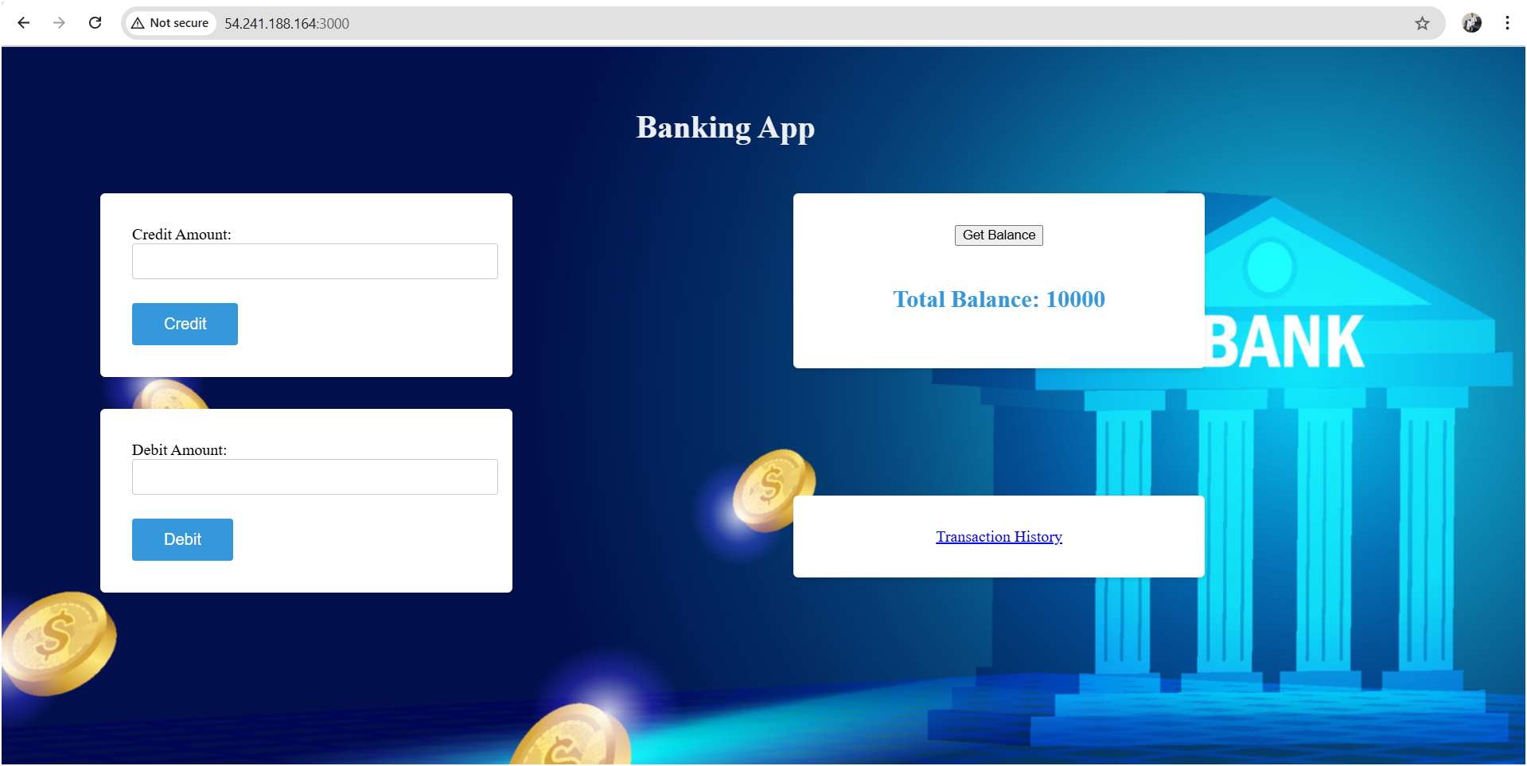

* Now how to check your data is stored in mongodb or not , follow the below steps.

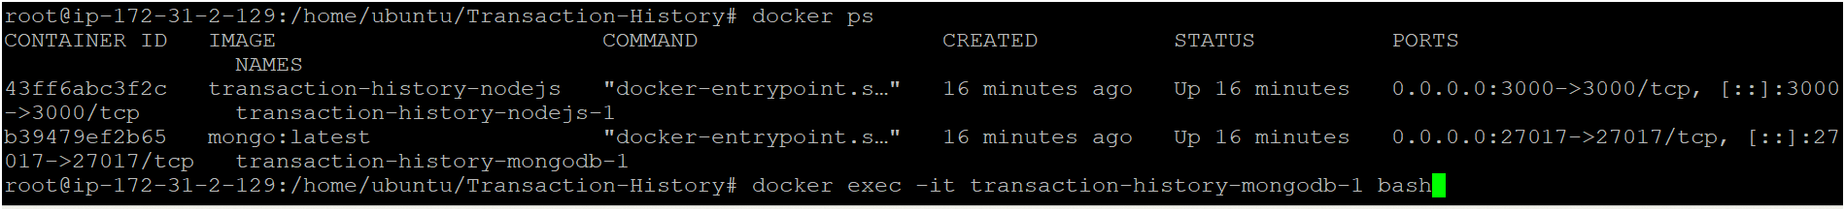



* Once inside the container, start the MongoDB shell using: mongosh

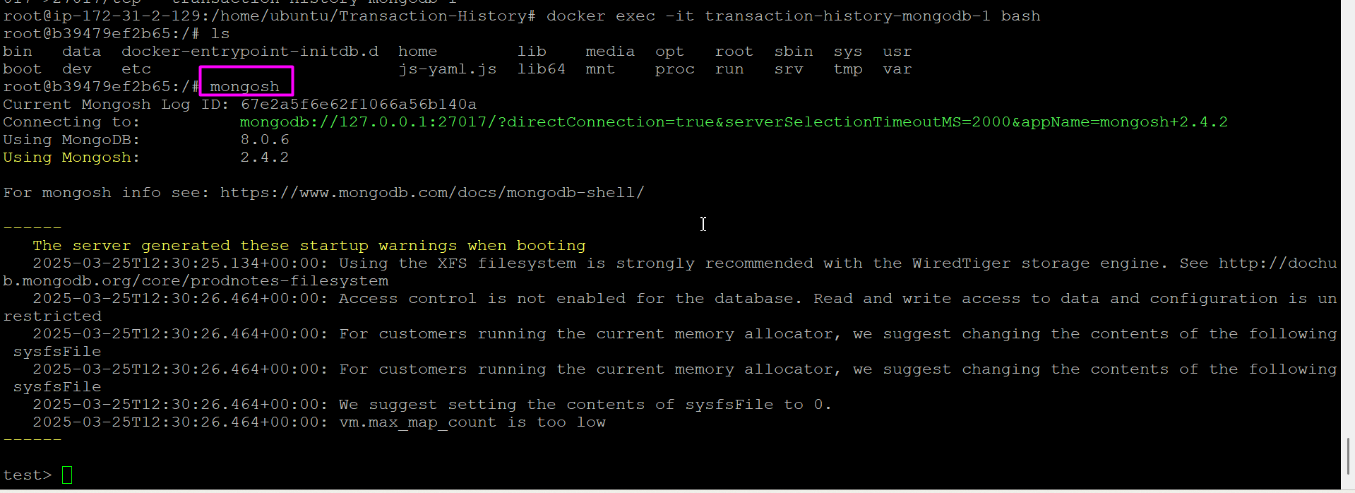

* Inside the MongoDB shell, run: show dbs

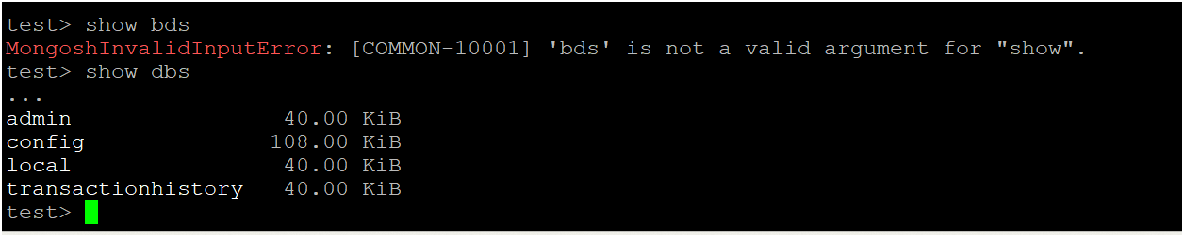

* Switch to a Database
* Select the database you want to view (replace <database_name> with the actual name):

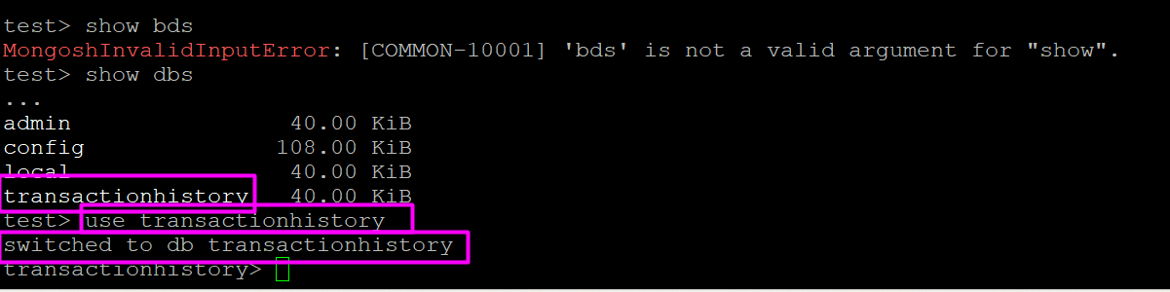

* To see the collections (similar to tables)

Run : show collections

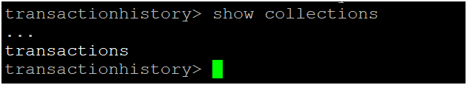

* To display the data in a collection, use:

db.transactions.find().pretty()

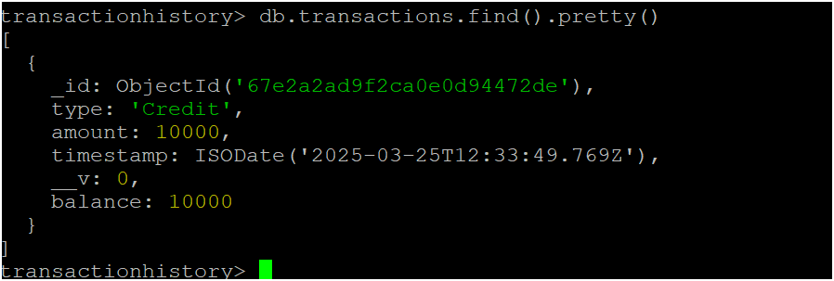

* Exit from mongo shell and container

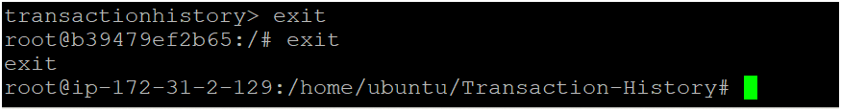

* Delete your ec2 instance and other resources which you used for this app.

AWS Configure : Enter the Credentials :

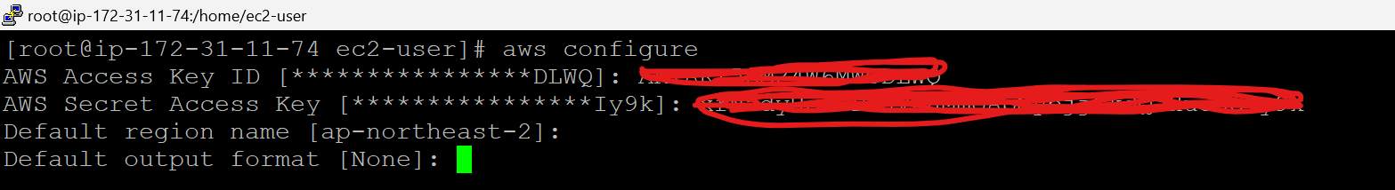

Install Necessary Dependencies using this Link :

**Install docker.sh**

<https://raw.githubusercontent.com/Msocial123/docker-install-commands/master/docker-install.sh>

curl https://raw.githubusercontent.com/Msocial123/docker-install-commands/master/docker-install.sh | sudo bash

**Install AWS CLI and other components:**

[**https://raw.githubusercontent.com/Msocial123/k8-install-eks/master/eks-client.sh**](https://raw.githubusercontent.com/Msocial123/k8-install-eks/master/eks-client.sh)

**Install Trivy Using this Command :**

**curl -sfL https://raw.githubusercontent.com/aquasecurity/trivy/main/contrib/install.sh | sudo sh -s -- -b /usr/local/bin**